**GSC USER GUIDE for GSC LEGEND RENDERER  
ADD-IN**

Version 1.3

Development: Gabriel Huot-Vézina  
AnalystS: Dave Everett, Katarzyna zawadzka   
Geological Survey of Canada, NRCAN

Contents

CONTACT INFORMATION iii

Suggestions for future versions iv

1 INTRODUCTION TO ADD-INS 5

1.1 Installation 5

1.2 Compatiblity 5

1.3 Uninstall 6

1.4 Updates 6

1.5 Language 6

1.6 Digital Signature 6

1.7 General Warning 7

1.8 Code repository 7

2 GSC LEGEND RENDERER 8

2.1 Main purpose 8

2.2 Style management 8

2.3 Working with a CGM template 8

2.4 Opening 9

2.5 Fields in the LEGEND TABLE 9

2.5.1 Legend table 9

2.5.2 Order 10

2.5.3 Column 11

2.5.4 Element 11

2.5.5 Style 1 11

2.5.6 Style 2 11

2.5.7 Label 1 11

2.5.8 Label 1 style 11

2.5.9 Label 2 12

2.5.10 Label 2 style 12

2.5.11 Heading 12

2.5.12 Description 12

2.5.13 DEM image in unit boxes 12

2.5.14 Auto-calculate number of columns (cgm only) 13

2.6 types of Legend elements 14

2.6.1 ANNO_BRACKET 14

2.6.2 ANNO_BREAK 14

2.6.3 BEACH 14

2.6.4 BLOB 15

2.6.5 BREAK 15

2.6.6 DUNES 15

2.6.7 HEADING1 15

2.6.8 HEADING2 15

2.6.9 HEADING3 15

2.6.10 HEADING4 16

2.6.11 HEADING5-HEADING5_END 16

2.6.12 LEFT BRACKETS 16

2.6.13 LANDSLIDE 17

2.6.14 LINE 17

2.6.15 MORAINES 17

2.6.16 NOTE 17

2.6.17 OVERLAY 18

2.6.18 POINT_CC 18

2.6.19 POINT_CC_45 18

2.6.20 POINT_LC_45 18

2.6.21 RIGHT BRACKETS 18

2.6.22 TOP_NOTE 19

2.6.23 TWOSIDE 19

2.6.24 TWOSIDE_FLIP 19

2.6.25 TWOSIDE_FLOW 19

2.6.26 UNIT_BOX 20

2.6.27 UNIT_INDENT-UNIT_INDENT2 20

2.6.28 UNIT_LINE 21

2.6.29 UNITS WITH EMBEDDED UNITS 21

2.6.30 WAVE 22

2.7 Missing values 23

2.8 Generated files 23

3 REFERENCES 25

4 APPENDIX 27

4.1 Problems and Errors 27

5 ANNEXES 28

5.1 Resulting legend graphic 28

5.2 Resulting legend table 30

5.3 Configuration Table 33

# CONTACT INFORMATION

**Contact for use of tools and technical issues:**

Gabriel Huot-Vézina

Geological Survey of Canada (Québec)

Phone: 418-654-3171

Email: [gabriel.huot-vezina@nrcan-rncan.gc.ca](mailto:gabriel.huot-vezina@nrcan-rncan.gc.ca)

# Suggestions for future versions

* Have a grouped graphic legend element that can move as a whole.
* Better legend management in a Canadian Geoscience map template.
  + Better fit on the right side if left brackets are found inside the legend table.
* Have a bit more space between a right bracket and its related UNIT_BOX element. Mimic what is done with left bracket.
* Add generation label to line symbol, just like the markers. Placement needs to go to the upper right of the lines, or possibly at one or another end of the lines to avoid overlapping predefined spaces like the gap between the symbols and the descriptions.

# INTRODUCTION TO ADD-INS

An add-in is a user-customized package for use within ArcGISTM Desktop applications. It represents a set of tools within a compressed file type that ends in “.esriaddin”.

The add-in described in this document was developed to provide a user-friendly interface to create and edit a standard GSC legend.

## Installation

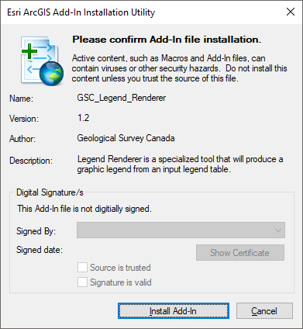NOTE: Arc Map must be closed during the install.

1. Download the most recent version of the Legend Renderer tool from [GCCode](https://gccode.ssc-spc.gc.ca/GSC-GDF/GSC-Legend-Renderer/-/releases).
2. Unzip the Legend Renderer ZIP file.
3. Double-click on the “*GSC_Legend_Renderer.esriAddIn*” file, stored within the folder of the same name.
4. Click on the “Install Add-in” button to complete the installation.

When installing the add-in, no administrator rights are needed and any user type can launch the tool.

These tools will only be available to whoever installed it since they are a feature of a user’s own personal ArcGIS set up.

Figure 1 Installation window.

TOOLTIP: If the add-in toolbar does not appear in ArcMapTM, open the Customize menu and open the Toolbars option. . Customize 🡪 Toolbars 🡪 GSC Cartography .

## Compatiblity

The tool was developed on ArcGISTM Desktop version 10.7 and was not tested in version 10.8.

## Uninstall

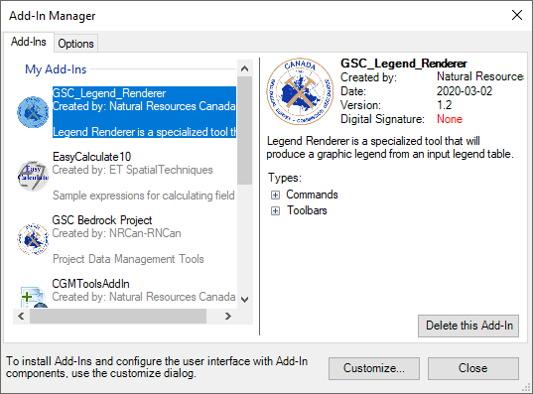All installations can be removed in ArcMapTM by accessing the Customize menu at the top of the screen and selecting the Add-in manager option.

Figure 2 Installed add-in window.

Customize 🡪 Add-in Manager 🡪 Delete this Add-in

## Updates

The add-in will be updated periodically with bug fixes. In this case, the user should uninstall the old add-in before the new installation.

## Language

The current user guide has been written in English, but all the tools, interfaces and error messages are available in French. French language is available when the operating system of the computer is also set to French.

## Digital Signature

A digital signature can be seen on the add-in installation window. This signature enables ArcGISTM to recognize that the add-in is installed by a trusted source. The digital signature is activated by the developer who will embed the security certificate within the Add-ins when they are created.

Installation problems could arise if the add-in is not signed correctly, but this should not prevent installation. Consult ESRI® help on how to change the default setting for ArcGISTM to accept Add-ins coming from any source, even if there’s no digital signature.

<http://help.arcgis.com/en/sdk/10.0/arcobjects_net/conceptualhelp/index.html#//0001000009w1000000>

## General Warning

The tool presented in this guide was developed in-house by NRCan employees. Any bugs or problems should be reported to the author. We recommend that users read this document prior to working with the tools to better understand any limitations. These tools were designed to assist the user in creating legends.

## Code repository

All the code written to create the tool is accessible on Github within the NRCan group located [here](https://github.com/NRCan/Legend-Renderer).

For any bug reports or feature addition, please either send an email to contact or create an account and fill in an issue directly on the project page from above link.

To make sure to get the latest .esriaddin file for installation, it is recommended to get it from the above link as it will always be the most recently updated.

# GSC LEGEND RENDERER

## Main purpose

This tool was developed to assist any user in creating a standard Canadian Geoscience Map (CGM) legend. By reading the data from an input legend table, the tool will be able to add proper graphic elements inside an ArcMapTM layout view. The legend will be fully compliant with standard procedure, from element ordering, text, description, labels, spacing between elements, and so on. Using a tool like this one can be a real time saver in which cartography workflow will be faster. It also offers flexibility when updates needs to be conducted on the legend without forcing the cartographer to manually do the edits. The tool only needs to be run again.

A working example can be found in annex 5.1.

## Style management

The tool is closely associated with the standard style file (GSC_SymbolStandard.style) used at the Geological Survey of Canada. It can be find along with the published standard (Geological Survey Canada, 2018). If this file is not loaded in the map document, a pop-up message will warn the user that it is required. The name of the desired features should be stored in STYLE fields in the form of an id like “1.01.01.001”.

**Note:** A different symbol style file can be used. See section 2.8 for more information.

## Working with a CGM template

The tool works in two types of map documents (.mxd), the default blank template or the standard CGM template used by the Geological Survey of Canada. If using a blank template, the legend is created in the middle of the dataframe in the layout view. If the tool runs inside a Canadian Geoscience Map template with full layout already filled, then the legend will replace the blue legend graphic seen at the far right.

NOTE: Use the Select Elements tool on the Drawing toolbar in ArcGIS to select legend elements.



Figure 3: Drawing toolbar with outline select tool.

## Opening

The tool is found under a toolbar named GSC Cartography, which contains only one button. Clicking the icon will open the tool main window.

## Fields in the LEGEND TABLE

The figures below section show the tool window with all of its required inputs. The first one being the legend table. This table should contain all legend items that will be converted into graphics and added to ArcMapTM layout view. See section 5 to learn more on how to properly build the awaited table and please consult the samples attached.

* + 1. Legend table

The input table can be in any of the following formats (extension):

* Shapefiles (.shp)
* Feature classes
  + File Geodatabase (.gdb)
  + Personal Geodatabase (.mdb)
* Tables
  + File Geodatabase (.gdb)
  + Personal Geodatabase (.mdb)
  + Database File (.dbf)
* Text files
  + Comma Separated Value (.csv)
  + Text (.txt)
    - Tab key separated values (“\t”)
    - Comma Separated values (“,”)
    - Semi-colon separated values (“;”)
* Excel Files
  + Office 1997 (.xls)
  + Office 2010 and higher (.xlsx)

Once a table is selected, the required input field names will automatically be filled if they exist in the table, if they are named just like stated in this document. Otherwise, user will need to manually select each of the needed fields. For example, if a input table has a field named like the following: Order, ORDER, order; it will be automatically selected inside the Order drop-down list because the tool knows what to look for. Else if the order field is named MY_ORDER_FIELD, it won’t be selected but still user can select it by himself. The figures below show an example of an automatically filled window.

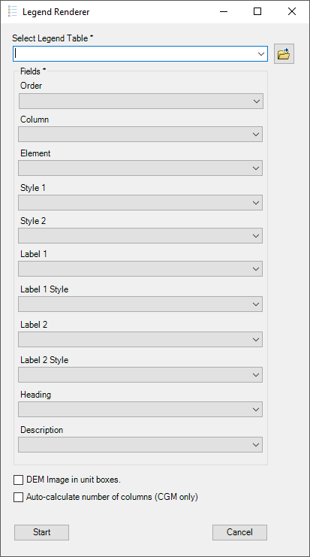 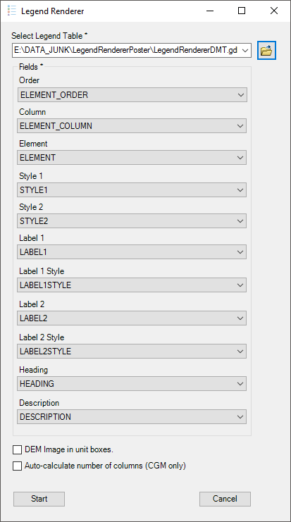

* + 1. Order

A numeric field that will sort the legend item hierarchy. Lower numbers will draw first in the legend.

We recommend using a decimal field type for update purposes. If an item needs to be inserted between two existing items, it is easy to do so by adding a decimal to the existing order. In the example below, two new items are inserted between items 2 and 3, without disrupting the whole table.

1-2-3-4-5 🡪 1-2-2.1-2.2-3-4-5

The tool filters all table rows based on this field before doing any processing. As a result, a legend table does not need to have its rows in the same order, as the output legends needs it. The user may wish to sort the table based on the ELEMENT_ORDER field for readability.

* + 1. Column

A nullable numeric field that states in which column the item needs to be added. A legend can expand across multiple columns for space-saving purposes. If nothing is entered, the item will be inserted in column 1 by default.

**Warning**: Number 0 is strictly used for right bracket elements. See section 2.6.1 more information.

**Note:** Within a CGM template, one can use the *auto-calculate column numbers* option to get a quick glance on how it should really look like within the template without much thinking about it. See section 2.5.14.

* + 1. Element

A text field that contains legend item types. For a full list of element names, please refer section 2.6 .

* + 1. Style 1

A text field that contains the main style identification for its associated element. The given id must be found inside loaded style file (GSCSymbolStandard for instance) to be properly drawn in the legend. This field is meant for any type of symbol: polygons, lines, points and text. For example, id “2.04.01.677” is to be used for a pink polygon fill.

* + 1. Style 2

A text field that contains secondary style identification. This field works exactly like Style 1 but is optional and only used in a small number of elements like UNIT_SPLIT or UNIT_LINE. See section 2.6.25 and 2.6.27 for more information.

* + 1. Label 1

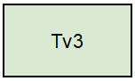This text field is required when an element needs a label to be added above or in front of it. Element UNIT_BOX is a good example where we see a label Tv3 that has been added to a green UNIT_BOX.

* + 1. Label 1 style

This text field defines a specific style identification used to draw the first (main) label, if needed. For examples, see Cartographic Symbol Standard for Geologic Map Production, 2019, section 2.2

* + 1. Label 2

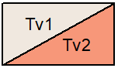This is field acts the same as Label 1 but is only used when an element needs a second label. The UNIT_SPLIT and POINT_CC_45 legend element types are good examples.

* + 1. Label 2 style

This fields acts the same as Label 1 style but is meant for secondary label, if any is needed.

* + 1. Heading

This text field is used for any heading text that needs to be inserted.

All heading elements (1 to 5) have to have some text in this field. In some other cases, if a bold font needs to be added before the start of a description, this field can be used jointly with description field for any other elements.

Elements of type HEADING5 are a special case since this element “groups” sub-elements underneath it with italic and indented text. In order to accomplish this, HEADING field must be filled and have the same text as the header. This will provide the tool information on where to start and end the grouping. For more information see section 2.6.11.

**Warning**: The use of a special font (like font GSCGeology2015.ttf) or style within the heading field needs to be set inside the text itself with special tags (<FNT>), for now. Code testing didn’t give good rendering output as of now. For more information on formatting tags in ArcGIS, please consult this ESRI [site](http://desktop.arcgis.com/en/arcmap/10.3/map/working-with-text/formatting-tags-available-in-arcmap.htm).

**Warning**: The use of this field along a description will set as bold the heading text within the description. Doing so ArcMap will try to make the whole text as HTML, since the code will add <BOL> tags to bold heading text. Using other special character like < in the description will break the HTML use and output the whole thing as not bold. For this special case, usage of HEADING and DESCRIPTION field used at the same time will force the tool to find any special character < and replace it with it’s counterpart HTML value, which is “&lt;”

* + 1. Description

Finally, this last fields (text) contains the full description of a legend item. Depending on which element this description needs to be inserted beside, text style can vary a bit. HEADING5 element description are a good example since the text will be set as italic.

**Warning**: The use of a special font (like font GSCGeology2015.ttf) or style within the heading field needs to be set inside the text itself with special tags (<FNT>), for now. Code testing didn’t give good rendering output as of now. For more information on formatting tags in ArcGIS, please consult this ESRI [site](http://desktop.arcgis.com/en/arcmap/10.3/map/working-with-text/formatting-tags-available-in-arcmap.htm).

**Warning**: The use of this field along a description will set as bold the heading text within the description. Doing so ArcMap will try to make the whole text as HTML, since the code will add <BOL> tags to bold heading text. Using other special character like < in the description will break the HTML use and output the whole thing as not bold. For this special case, usage of HEADING and DESCRIPTION field used at the same time will force the tool to find any special character < and replace it with it’s counterpart HTML value, which is “&lt;”

* + 1. DEM image in unit boxes

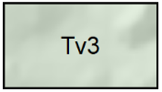Checking this option box will provide a digital elevation model (DEM) type of hillshade under the colored unit boxes that will be set 30 % transparent. This option is mainly used for surficial type of legends.

* + 1. Auto-calculate number of columns (cgm only)

This will give the opportunity, if used within a CGM template map document (.mxd), to let the tool put in the elements in different columns based on the layout height. All values inside COLUMN field will be ignored if this option is checked.

**Warning**: This option can given a quick rendering look on how many columns is needed, however it is not a perfect solution and some small manual replacement might be needed.

## types of Legend elements

Below sections describes and shows all element types, in alphabetical order, that are managed by the legend renderer. The element type must be properly written and stored inside legend table field ELEMENT. A visual example is available in the annexe 5.1.

Some basics rules needs to be known before building a legend and that is regarding the order of its inner elements. As a main rule, unit boxes will always appear above any line, polygons or marker symbols. Then comes marker symbols, lines and polygons. Failing to follow this rule might result in symbols overlapping each other or other unknown rendering behavior. This simple rule enacted as the main foundation of an extended list of height spacing or Y axis spacings between every elements types. For example, what is the Y axis space required between a UNIT_BOX and a subsequent DUNES symbols. All of those configurations are made available within a JSON text file (.json), which can be edited, please refer to section 2.8.

* + 1. ANNO_BRACKET

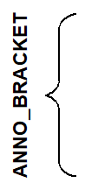This element is a vertical text that will be placed beside a left bracket that embraces some unit boxes. By default any text found in LABEL1 field of this element will be set as capital and bold so style field doesn’t have to be filled. Vertical center of the text will be placed along side center of the bracket.

**Warning**: Only compliant with UNIT_BOXES.

* + 1. ANNO_BREAK

This type of element can be used to add some text over a BREAK element. LABEL1 field text will be placed over the line. Style field for this element doesn’t have to be filled.



**Warning**: Must be used after a BREAK element.

* + 1. BEACH

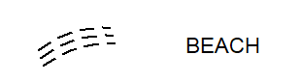Beach element are mainly used in surficial project. The style of the lines can be changed inside STYLE1 field.

* + 1. BLOB

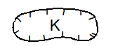Blobs can be used for symbology that has a polygonal look, for example kettle. STYLE1 field will define the style of the ring portion. Optionally, to define a label in the center of the blob fill LABEL1 field with appropriate font number and in LABEL1STYLE insert font style id.

* + 1. BREAK

This linear type of element can be used to make a clean distinction between sets of elements. Text can be put over the line if used with an ANNO_BREAK element.



**Warning**: Must be used before an ANNO_BREAK element.

**Note**: The style field for this element does not have to be filled, but can be changed if required

* + 1. DUNES

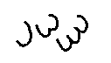Dunes element are mainly used in surficial project. The style of the lines can be changed inside STYLE1 field.

* + 1. HEADING1

First heading element text will automatically be set with capital and bold font. The text can be changed inside the HEADING field.

**Note**: The style field for this element does not have to be filled, but can be changed if required.

* + 1. HEADING2

Second set of heading will automatically be set with capital and bold font. The text can be changed inside HEADING field.

**Note**: The style field for this element does not have to be filled, but can be changed if required.

* + 1. HEADING3

This type of heading contains a description that can be added to DESCRIPTION field. The bold and capital part will be set automatically with the text found in HEADING field.

**Note**: The style field for this element does not have to be filled, but can be changed if required.

* + 1. HEADING4

Fourth set of heading will automatically be set with capital and bold font. The text can be changed inside HEADING field.

**Note**: The style field for this element does not have to be filled, but can be changed if required.

* + 1. HEADING5-HEADING5_END

This particular type of heading is meant to be used with symbols under a same theme that needs to be grouped visually. Text in HEADING field is kept as is, contrary to other types of heading.

This grouping results in the following legend:

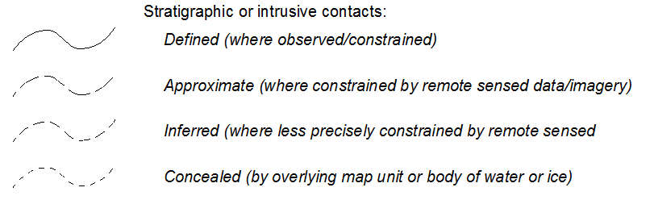

In order for the grouping to occur, there is two way of working. Either use the element name HEADING5_END as a new row in the legend table to stop the grouping. Or by duplicating the heading text in the HEADING field. This method will provide enough information for the tool to know when to start and end the symbol grouping.

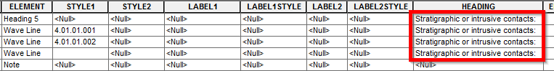

**Note**: The style field for this element does not have to be filled, but can be changed if required.

* + 1. LEFT BRACKETS

Left brackets come in two pieces, an upper one and a lower one. Both parts delimits what the bracket embraces.

To add some text description what is inside the bracket, please refer to element ANNO_BRACKET section 2.6.1

**Warning**: Only compliant with UNIT_BOXES.

#### L_BRACKET_U

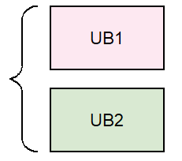L_BRACKET_U stands for left bracket upper part element. This element sets where the whole bracket begins. It must be added before the first element that will be bracketed.

#### L_BRACKET_L

L_BRACKET_L stands for left bracket lower part element. This element sets where the whole bracket ends. This element must be added after the last common element that will be bracketed.

* + 1. LANDSLIDE

Landslide elements are mainly used in surficial projects. Their style can be changed in STYLE1 field.

* + 1. LINE

Line elements are defined as a straight line. Their style can be changed in STYLE1 field.

* + 1. MORAINES

Moraine elements are mainly used in surficial projects. Their style can be changed in STYLE1 field.

* + 1. NOTE

A note element is a text block that is set to the same width as the legend column. The text can run across multiple lines and must be added to the DESCRIPTION field. Style field for this element can be <NULL>.

Header field can also be used with this element. The text found in the header will be added before the note description as bold text.

**Note**: This element will always have a left aligned text.

* + 1. OVERLAY

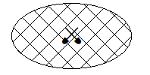An overlay symbol defines overlay units with a pattern symbol. Pattern style can be set in STYLE1 field. Optionally a marker can be added to its center in STYLE2 field. If a label, instead of a marker is needed in the center, LABEL1 and LABEL1STYLE fields can be used instead.

* + 1. POINT_CC

This element is a marker symbolized with STYLE1 field. Optionally, a label can be added to the upper right portion. LABEL1 and LABEL1STYLE fields can be used to define it.

* + 1. POINT_CC_45

A special marker symbol in which a 45-degree rotation is applied to best represent them. Mainly used for measured type of markers.

Two labels can be added to it, one above the other. LABEL1 field will always appear beneath the LABEL2 value at the left of the symbol.

Both label fields are optional.

* + 1. POINT_LC_45

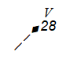This linear type of marker has a 45-degree rotation to it. The main difference between this symbol and POINT_CC_45 is the rotation anchor, which in current case is lower left. Just like POINT_CC_45, this element can optionally have two labels added to it. Two labels can be added to it, one above the other. LABEL1 field will always appear beneath the LABEL2 value at the righ of the symbol.

Both label fields are optional.

* + 1. RIGHT BRACKETS

Like the Left Brackets, right brackets are defined by two parts, an upper and a lower one. Right brackets could also be set to regroup other set of right brackets.

To correctly place an item on the right side of the bracket it is the same procedure as adding any other item except that COLUMN field must be set to 0 and it must be found between R_BRACKET_L and R_BRACKET_U items. Please refer to annexes for an example table.

**Warning**: This element should only to be used with a maximum of two UNIT_BOX elements

**Warning**: Embedded elements in a right bracket must have 0 as their column number.

#### R_BRACKET_U

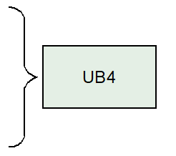This element name defines the start of a right bracket upper part. Just like the left bracket symbol, adding this element before the first embraced item will help the tool know when to start the drawing of the bracket.

#### R_BRACKET_L

This element name stands for a right bracket lower part. Just like the left bracket symbol, adding this element after the last embraced item will help the tool know when to end drawing the bracket.

* + 1. TOP_NOTE

A top note element is a text block that is set to the same width as the legend column and has centered aligned text. It can run across multiple lines and must be added to the DESCRIPTION field. The style field for this element can be NULL.

The header field can also be used with this element. The text found in the header field will be added before the note description as bold text.

**Note**: This element will always have a center-aligned text.

* + 1. TWOSIDE

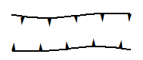This linear type of symbol draws two opposite lines symbolized in the same manner with the STYLE1 field.

* + 1. TWOSIDE_FLIP

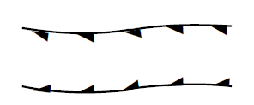This linear type of symbol draws two opposite lines symbolized with two different line style. Top line will be set by STYLE1 and the bottom one with STYLE2 field.

* + 1. TWOSIDE_FLOW

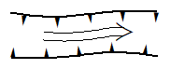This type of linear symbol contains three part, two outer lines and one inner line. The outer lines are symbolized with the STYLE1 field and the inner part with the STYLE2 field.

* + 1. UNIT_BOX

This rectangular element is used to designate mapping units. To set the background color of the unit, set the style in theSTYLE1 field.

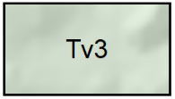If the DEM option has been checked, a hillshade background will be added to it.

If the HEADING field is filled with text, that text will be added to the start of the description and automatically set as bold.

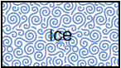Finally, if an overlay type of color has been selected in STYLE1 field, the color of this overlay can be set in STYLE2 field.

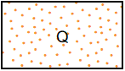

* + 1. UNIT_INDENT-UNIT_INDENT2

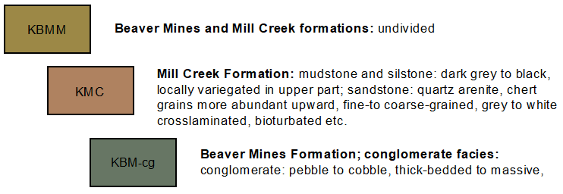  
A UNIT_INDENT and UNIT_INDENT2 introduces another way, beside HEADING, UNIT_PARENT/UNIT_CHILD, UNIT_SPLIT, right and left brackets of showing possible relation between units.

By default UNIT_INDENT boxes aligned with the middle of a UNIT_BOX and UNIT_INDENT2 will be aligned with the middle of a UNIT_INDENT element. In this last case it also aligns with the far right end of a UNIT_BOX.

These element types can be used just like any other UNIT_BOX element, meaning overlays can be set within fields STYLE1 and STYLE2 and DEM option checked can be checked.

If the HEADING field is filled with text, it text will be added to the description and automatically set as bold.

* + 1. UNIT_LINE

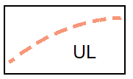A UNIT_LINE is a UNIT_BOX with a symbolized line in it instead of a simple colored background. The line color can be changed with the STYLE1 field and the line symbol style with STYLE2 field. A label can also be added, if needed. This element is useful for units that are very thin in width.

If the HEADING field is filled with text, it text will be added to the description and automatically set as bold.

* + 1. UNITS WITH EMBEDDED UNITS

It is possible to have units embedded into each other in a vertical manner. This type of element is composed of two different type of sub elements, a parent element (UNIT_PARENT) and a child (UNIT_CHILD or UNIT_CHILD_LINE). There is no limit to the number of children.

#### UNIT_PARENT

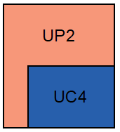This element is a larger UNIT_BOX with at least one smaller nested units. It acts just like a normal UNIT_BOX and the color of its background is set within STYLE1 field.

Visually, if the description of a UNIT_PARENT is long and extends on multiple lines, the start XY placement of a UNIT_CHILD will move farther beneath it resulting in a UNIT_PARENT head bigger then usual.

If the HEADING field is filled with text, it will be added before the description and automatically set as bold.

**Warning**: the DEM option is not available for UNIT_PARENT elements.

#### UNIT_CHILD

The UNIT_CHILD element is the inner part of a UNIT_PARENT element. It works just like a normal UNIT_BOX but instead is smaller in width and nested.

If the HEADING field is filled with text, it will be added before the description and automatically set as bold.

**Warning**: the DEM option is not available for UNIT_PARENT elements.

#### UNIT_CHILD_LINE

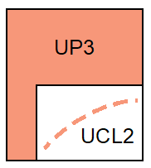The UNIT_CHILD_LINE element acts just like a normal UNIT_LINE element but is nested inside a UNIT_PARENT and a bit smaller in width.

The line color can be changed with the STYLE1 field and the line symbol style with the STYLE2 field. A label can also be added, if needed.

If the HEADING field is filled with text, it will be added before the description and automatically set as bold.

#### UNIT_SPLIT

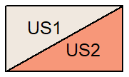This map unit element contains two different unit divided with a diagonal line. LABEL1 field is used for the upper left unit, and LABEL2 field for the lower right one. The left background can be changed with the STYLE1 field and the right background with the STYLE2 field.

If the HEADING field is filled with text, it will be added before the description and automatically set as bold.

**Warning**: the DEM option is not available for UNIT_SPLIT elements.

* + 1. WAVE

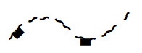This linear symbol element can be set with the STYLE1 field and acts just like a LINE element, but with a curve.

## Missing values

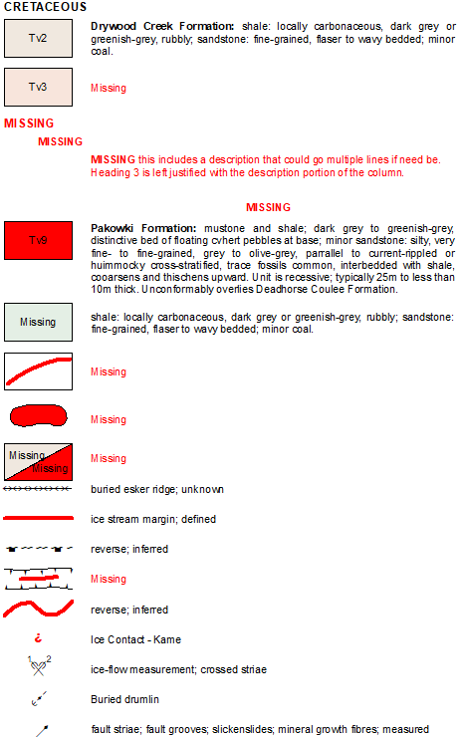If for any reason a description, a label or a style is missing from the legend table, a visual cue in red will be added to the legend, without interfering with the overall process. The User then must assess the missing piece and correct it in the table. As shown in the figure to the left, a missing description or heading will be seen as a “Missing” red text.

A missing map unit color or polygon symbol will be drawn in red.

A missing style for lines will be set as plain and bold red.

A missing style for a marker will be a red and bold inverted question mark.

## Generated files

This tool will save some files on the user’s computer. Those files are all saved inside the folder named “GSC_Legend_Renderer X” added to the user’s “My documents\ArcGIS” folder. X being the esri add-in version number. Here is the generated file list:

* LegendRendererTemplate.mxd: The map document template that will be used to extract standard graphic elements. Those blank styled elements will be copied into the user’s document, then properly placed and symbolized. This file can be updated if any minor modifications are needed to a graphic element.
* XSpacing.json: This text based file contains all the required standard horizontal spacing between all of the legend items. For example, the required gap between an element symbol and its related description is defined as 5 millimeters (mm). All numbers in this file are in mm and also contains some standard width values as well as the horizontal spacings.
* YSpacing.json: This text based file contains the required standard vertical placement values between all of the legend items. For example, the required space between a UNIT_BOX and a HEADING4 element is set to 5 mm. All numbers in this file are in mm.
* OtherComponents.json: This text based file contains the style file name used by the tool to gather information related on how to symbolized the legend elements. It also contains the name of a special font that might be used inside any text, within the legend, and found inside <FNT> tags. By default those values are set to GSCSymbolStandard and GSCGeology2015, but a user could edit them if those two gets renamed or user needs to do testing with some other files of their own. Finally, it also contains the default value for the DEM opacity, which is set to 70% opaque.
* LegendBoxDEM.png: This picture file will be used to create a colored version of itself and add it as background to a UNIT_BOX if the option is checked in the main menu of the tool.
  + For time saving purposes, all colored background that contains a DEM hillshade will see a copy of it stored along side of this picture file. If the tool has created a red colored hillshade, and the user must relaunch the tool, if the file already exists, it will not be created again. This is why it is always faster to run the tool a second time.

# REFERENCES

*Geological Survey Canada, 2020. Cartographic symbol standard for geologic map production; Geological Survey of Canada, Open File 8572, 104p.* [*https://doi.org/10.4095/327025*](https://doi.org/10.4095/327025)

# APPENDIX

## Problems and Errors

* When using a legend from an Excel file (.xls, .xlsx), long text fields are truncated to 255 maximum when processed with the Legend Renderer Tool, just like in shapefiles (.shp). This is a known problem in ESRI software.

# ANNEXES

## Resulting legend graphic



## Resulting legend table

Previous section graphic legend was processed with the legend table below, also available in a File Geodatabase version here:   
<https://gccode.ssc-spc.gc.ca/GSC-GDF/GSC-Legend-Renderer/-/wikis/uploads/1b524ab2bb548708220030b2f3907869/LegendRenderer_v1_2.gdb.zip>

## Configuration Table

This next table shows the settings that were used to create template graphics, found in LegendTempate.mxd, used by the Legend Renderer tool.

|  |  |  |  |  |  |  |  |  |
| --- | --- | --- | --- | --- | --- | --- | --- | --- |
| ELEMENT | ANCHOR | X-OFFSET | WIDTH | HEIGHT | OUTLINE | Style | SPECS | NOTES |
| HEADING1 | UL | * | 120 max. | 3.547 |  | 2.02.01.001 | Arial Bold; 9 pt; CAPS; LEFT | Usually not multi-line |
| HEADING2 | UL | 9.0 | 111 max. | 3.153 |  | 2.02.01.002 | Arial Bold; 8 pt; CAPS; LEFT | Usually not multi-line |
| HEADING3 | UL | 21.0 | 99 max. | ~ |  | 2.02.01.003 | Arial ; 8 pt; U/L; LEFT | Could be multi-line; Heading portion should be Bold and CAPS: Description portion Regular and u/l |
| HEADING4 | UC | 70.5 | 99 max. | ~ |  | 2.02.01.004 | Arial ; 8 pt; CAPS; CENTER | Usually not multi-line |
| HEADING5 | CL | 21.0 | 99 max. | 3.153 |  | 2.02.01.005 | Arial ; 8 pt; U/L; LEFT | Usually not multi-line |
| HEADING5_END | This is not a graphic but more of statement for the code | | | | | | | |
| DESCRIPTION | UL or CL | 21.0 | 99 max. | ~ |  | 2.02.01.006 | Arial ; 8 pt; U/L; LEFT | If heading then HEADING: DESC / If height <10.0 then CL origin at BOX - 5.0 |
| NOTE | UC |  | 120 max. | ~ |  | 2.02.01.008 | Arial ; 8 pt; U/L; CENTER | Could be multi-line |
| ANNO_BRACKET | CR | -4.5 | 99 |  |  | 2.02.01.009 | Arial Bold; 8 pt; CAPS; CENTER | Text rotated 90° counterclockwise |
| ANNO_BREAK | CC | 60.0 | 120 max. | 4.5 |  | 2.02.01.010 | Arial ; 8 pt; U/L; CENTER | 2 mm white halo exists to knock out break line |
| UNIT_BOX | UL |  | 18.0 | 10.0 | 0.25 |  |  |  |
| UNIT_INDENT | UL |  | 18.0 | 10.0 | 0.25 |  |  |  |
| UNIT_INDENT2 | UL |  | 18.0 | 10.0 | 0.25 |  |  |  |
| UNIT_SPLIT | UL |  | 18.0 | 10.0 | 0.25 |  |  |  |
| UNIT_PARENT | UL |  | 18.0 | 10.0 + (10.0 * Number of children) | 0.25 |  |  |  |
| UNIT_CHILD | UL | 4.0 | 14.0 | 10.0 | 0.25 |  |  |  |
| UNIT_LINE | UL |  | 18.0 | 10.0 | 0.25 |  |  |  |
| OVERLAY | UL |  | 18.0 | 10.0 |  |  |  |  |
| BREAK | CL |  | 120.0 |  |  |  |  |  |
| BLOB | CC | 1.5 | 15.0 | 5.8 |  |  |  |  |
| WAVE | CC |  | 18.0 | 4.0 |  |  |  |  |
| LINE | CC |  | 18.0 | ~ |  |  |  |  |
| TWOSIDE | CC |  | 18.0 | 5.8 |  |  |  |  |
| TWOSIDE_FLIP | CC |  | 18.0 | 5.8 |  |  |  |  |
| TWOSIDE_FLOW | CC |  | 18.0 | 5.8 |  |  |  |  |
| BEACH | CC | 4.0 | 10.0 | 5.0 |  |  |  |  |
| DUNES | CC | 4.0 | 10.0 | 5.0 |  |  |  |  |
| LANDSLIDE | CC | 4.0 | 10.0 | 5.0 |  |  |  |  |
| MORAINE | CC | 4.0 | 10.0 | 5.0 |  |  |  |  |
| POINT_CC | CC |  |  |  |  |  |  |  |
| POINT_CC_45 | CC |  |  |  |  |  |  |  |
| POINT_LC_45 | LC |  |  |  |  |  |  |  |
| L_BRACKET_L | UR | -2 | 2.5 | 2.5 | 0.20 |  |  |  |
| L_BRACKET_C | CR | -4.5 | 2.0 | 5.0 | 0.20 |  |  |  |
| L_BRACKET_U | LR | -2 | 2.5 | 2.5 | 0.20 |  |  |  |
| BRACKET_SPINE | UC |  | 0.0 | ~ | 0.20 |  |  |  |
| R_BRACKET_L | UL |  | 2.5 | 2.5 | 0.20 |  |  |  |
| R_BRACKET_C | CL |  | 2.0 | 5.0 | 0.20 |  |  |  |
| R_BRACKET_U | LL |  | 2.5 | 2.5 | 0.20 |  |  |  |
| UNIT_CHILD_LINE | UL | 4.0 | 14.0 | 10.0 | 0.25 |  |  |  |